Pre-School’s Home task 7-2-24
Let’s Perform! Return by Wednesday 21st February
Singing Nursery Rhymes helps young children to develop vital pre-reading skills as they gain an awareness of rhyme, alliteration and story sequence. Since starting Pre-School we have been learning the Nursery Rhyme – Baa Baa Black Sheep. For this week’s Home task we are asking you to share this rhyme with your child.
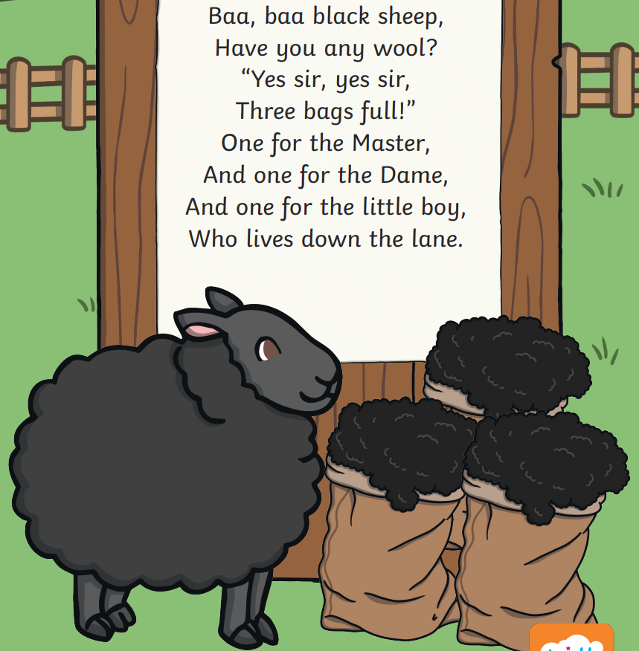

EYFS Objectives
Completing this activity with your child helps them reach these age related expectations:
Communication and Language: Expressive Arts and Design
Sing a large repertoire of songs To remember and sing entire songs
Know many rhymes
Name:
Let’s Perform
Did your child enjoy this Nursery Rhyme?

Could they join in with the whole song?

What actions did they do when they sang it?

What other Nursery Rhymes do they know.?

