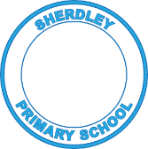
Sherdley Primary School 2022-23
RE Progression Statements – End of year expectations for Early Years

 | Beliefs and Values | Living Religious Traditions | Shared Human Experience | Search for Personal Meaning
EYFS | - Can recall parts/characters of a religious story | - Can recall some practices/events from a religious celebration | - Notice and understand how people are kind to each other and how we help others in need | - Can listen and ask questions about some events in stories and celebrations

