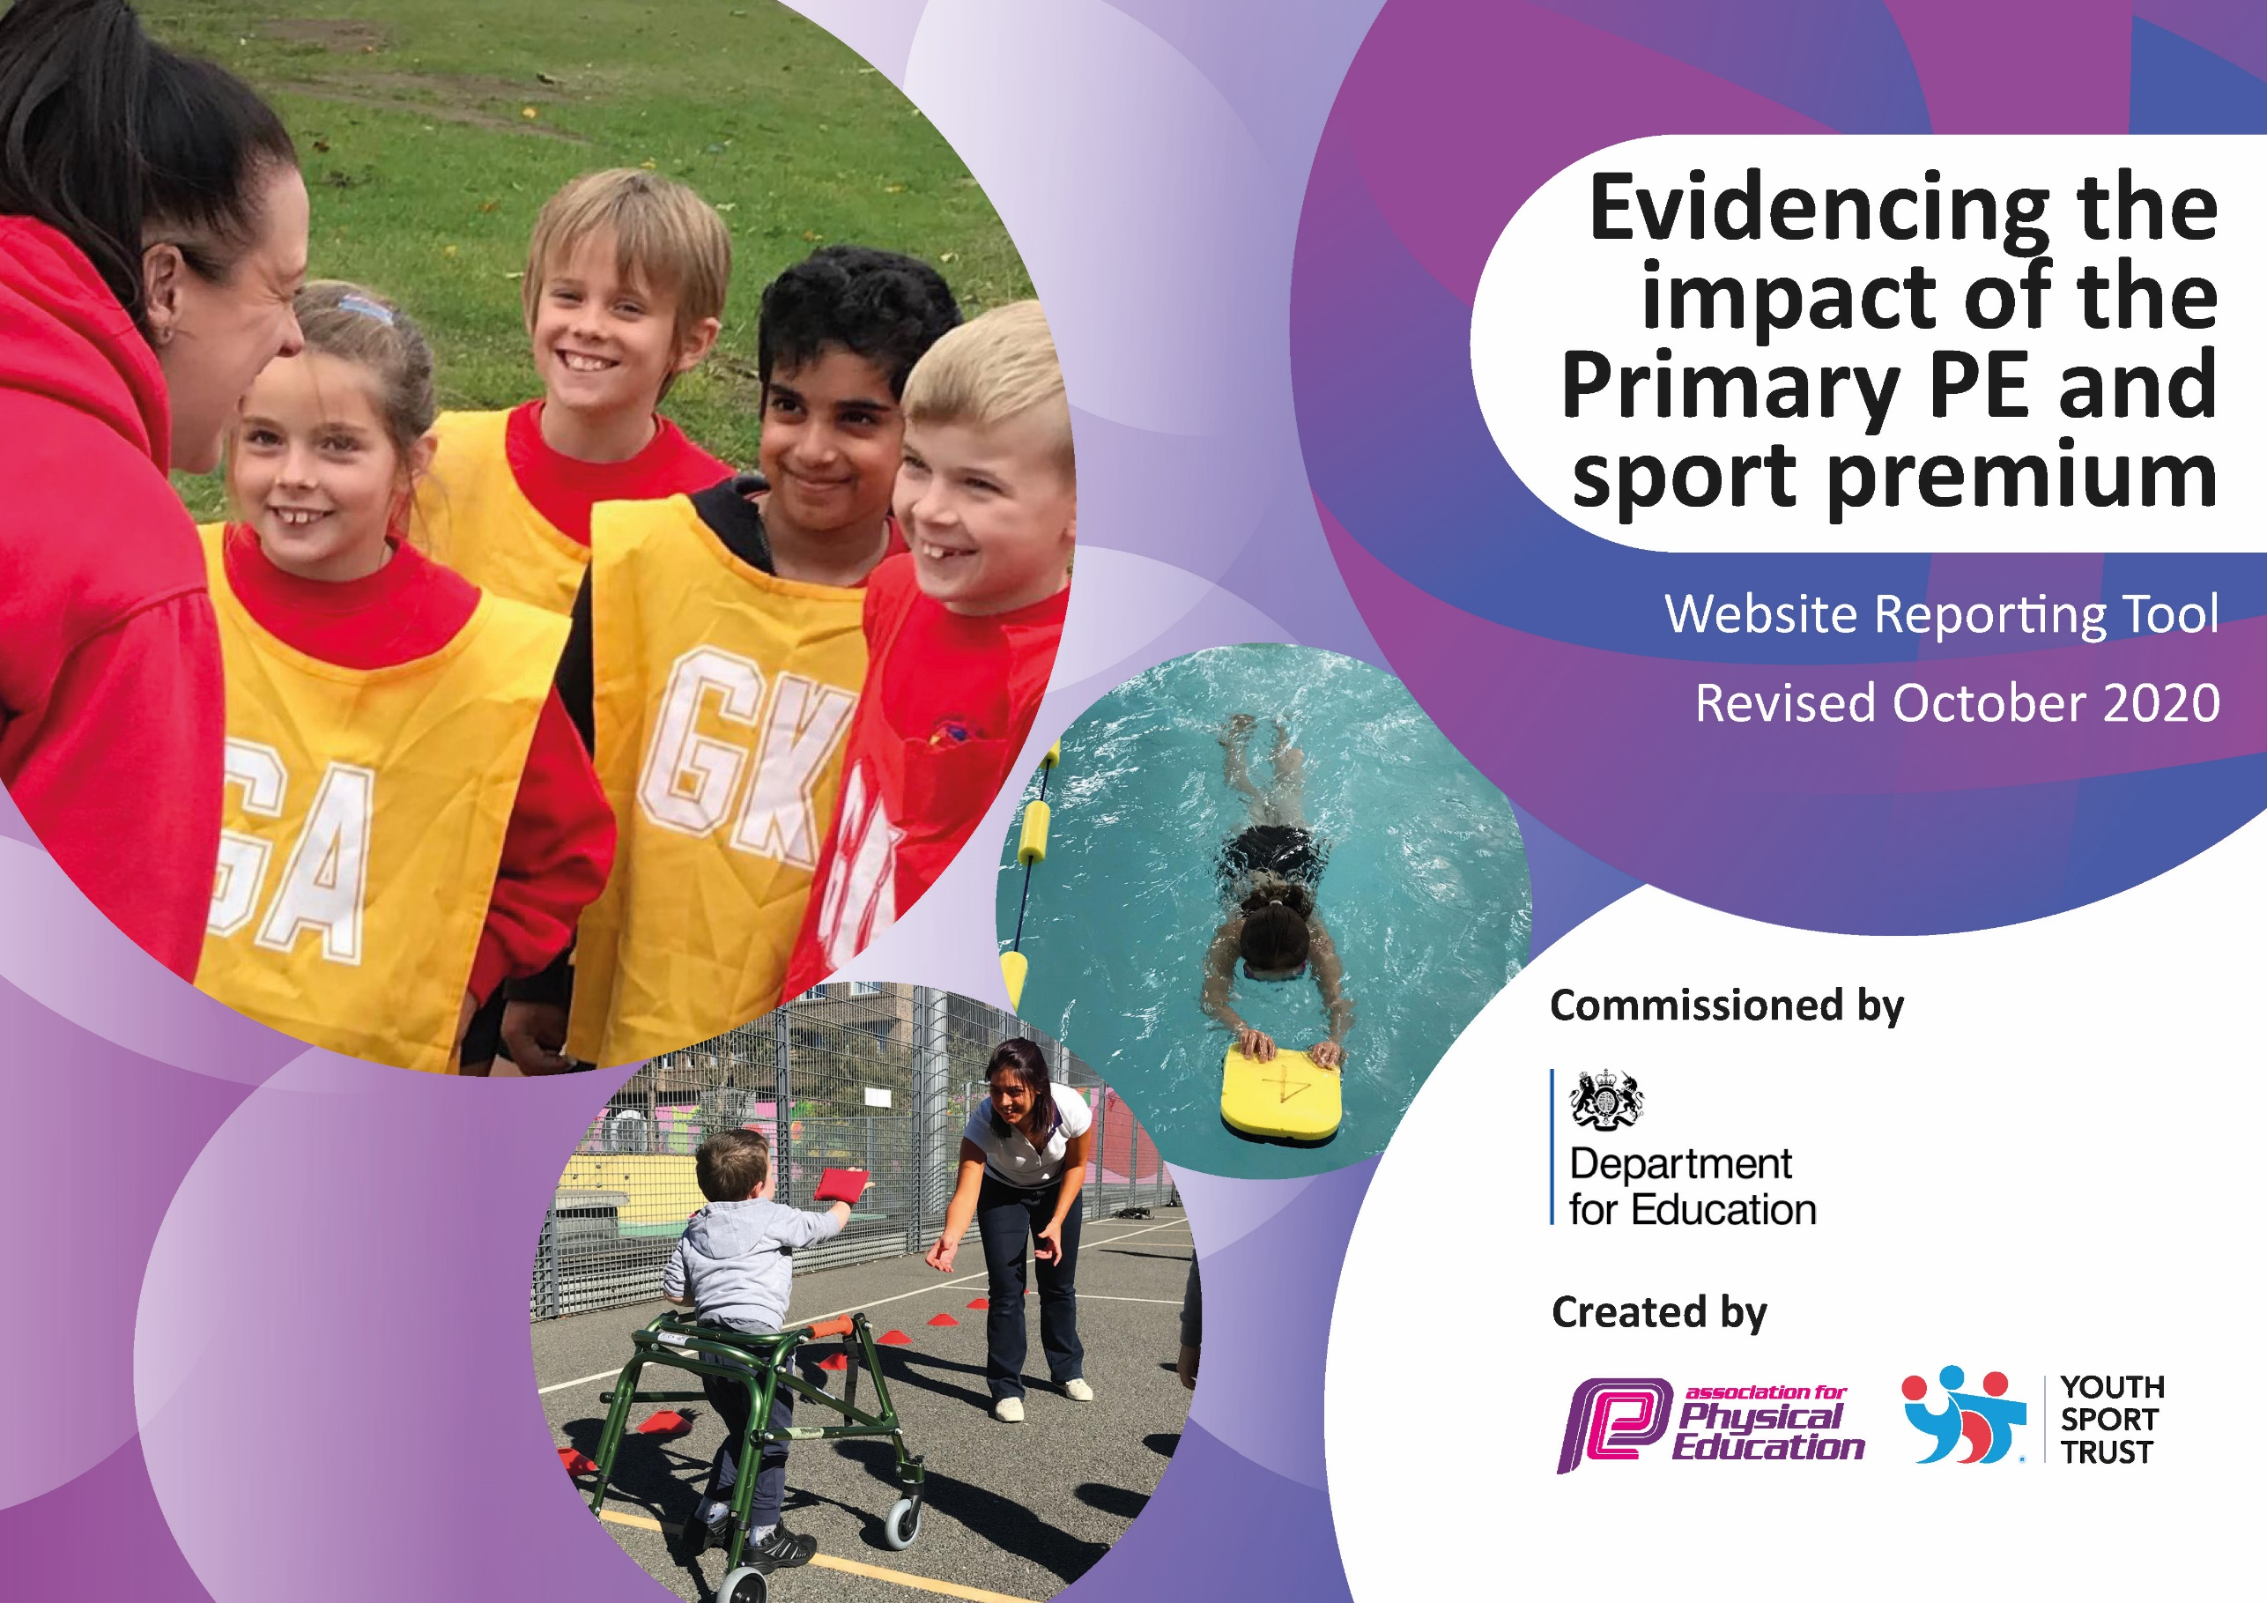
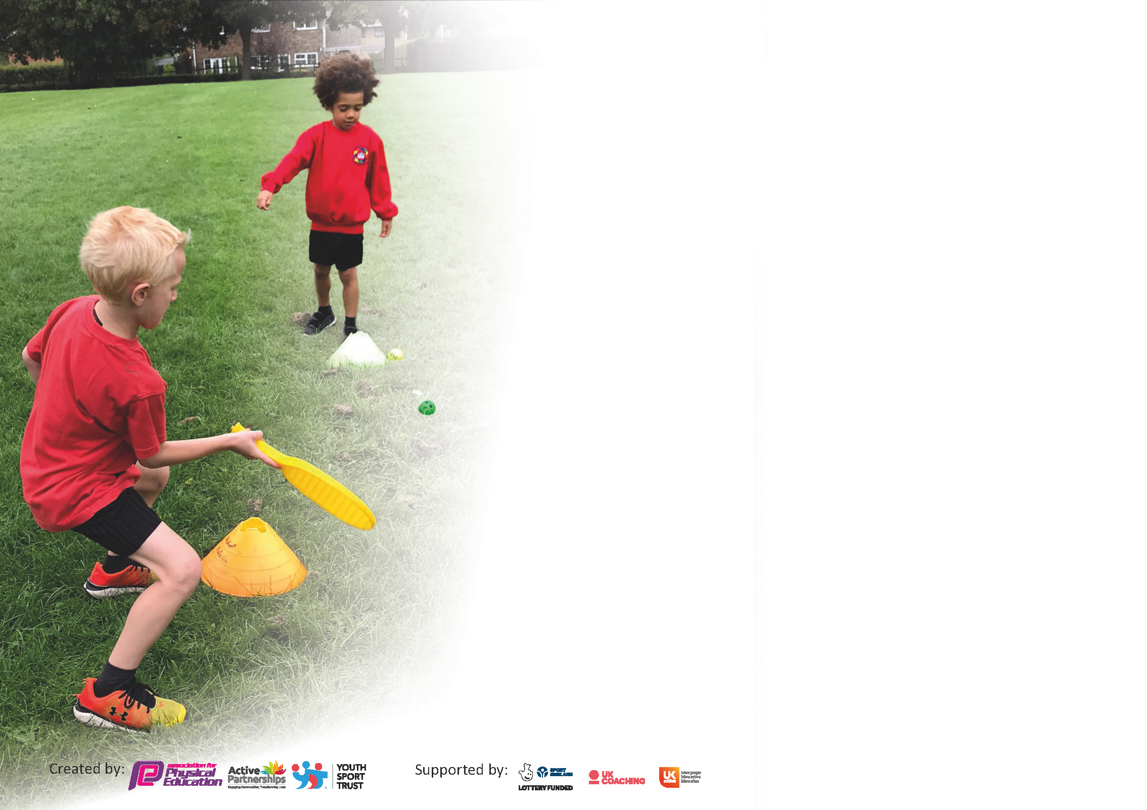

It is important that your grant is used effectively and based on school need. The Education Inspection Framework (Ofsted 2019 p64) makes clear there will be a focus on ‘whether leaders and those responsible for governors all understand their respective roles and perform these in a way that enhances the effectiveness of the school’.

Under the Quality of Education criteria (p41) inspectors consider the extent to which schools can articulate their curriculum (INTENT), construct their curriculum (IMPLEMENTATION) and demonstrate the outcomes which result (IMPACT).

To assist schools with common transferable language this template has been developed to utilise the same three headings which should make your plans easily transferable between working documents.

Schools must use the funding to make additional and sustainable improvements to the quality of Physical Education, School Sport and Physical Activity (PESSPA) they offer. This means that you should use
the Primary PE and sport premium to:

- Develop or add to the PESSPA activities that your school already offer
- Build capacity and capability within the school to ensure that improvements made now will benefit pupils joining the school in future years

Please visit gov.uk for the revised DfE guidance including the 5 key indicators across which schools should demonstrate an improvement. This document will help you to review your
provision and to report your spend. DfE encourages schools to use this template as an effective way of meeting the reporting requirements of the Primary PE and sport premium.

We recommend you start by reflecting on the impact of current provision and reviewing the previous spend.

Schools are required to publish details of how they spend this funding as well as on the impact it has on pupils’ PE and sport participation and attainment by the end of the summer term or by 31st July 2023 at the latest.

We recommend regularly updating the table and publishing it on your website throughout the year. This evidences your ongoing self-evaluation of how you are using the funding to secure maximum, sustainable impact. Final copy must
be posted on your website by the end of the academic year and no later than the 31st July 2023.
Created by: Supported by:

Support for review and reflection - considering the 5 key indicators from DfE, what development needs are a priority for your setting and your pupils now and why? Use the space below to reflect on previous spend and key achievements and areas for development.
Key achievements to date until July 2023: | Areas for further improvement and baseline evidence of need:
- Employment of a part-time dedicated Sports Coaches from The Saints Rugby Foundation  - Reviewed the curriculum map for 2022-2023 to ensure each year group has a broad & balanced PE curriculum. Completed the progression maps for each year group.  - Created a school notice board in KS2 for promoting and raising the profile of PE.  - Range of extra-curricular clubs provided by sports coaches and staff.  - Walk to school initiative – WOW | - Arrange suitable training and support for Sports Leaders  - Research best PE Planning tool  - Engage more sports coaches for after-school provision.  - Develop further links with The Academy to engage in more intra school events.  - Ensure more year groups access swimming lessons  - Staff taking children swimming to access training if not already done

Meeting national curriculum requirements for swimming and water safety.  N.B Complete this section to your best ability. For example you might have practised safe self-rescue techniques on dry land. | This section cannot be completed – local pool closed due to structural issues in Spring 2020, new pool not yet ready to open. Local Authority provision suspended. Lockdowns impacted on termly swimming. No swimming for Y5 during the academic year 2020-21.  Swimming restarted in Summer 22, but Y5 & 6 classes only had 2 lessons each due to restrictions on pool time and timetabling issues.  Swimming restarts for Y5 & 6 in summer 2023, each class having 3 weekly swimming lessons
What percentage of your current Year 6 cohort swim competently, confidently and proficiently over a distance of at least 25 metres?  N.B. Even though your pupils may swim in another year please report on their attainment on leaving primary school at the end of the summer term 2020. | N/A
What percentage of your current Year 6 cohort use a range of strokes effectively [for example, front crawl, backstroke and breaststroke]? | N/A
What percentage of your current Year 6 cohort perform safe self-rescue in different water-based situations? | 100%
Schools can choose to use the Primary PE and sport premium to provide additional provision for swimming but this must be for activity over and above the national curriculum requirements. Have you used it in this way? | No, due to no availability of a pool.

Action Plan and Budget Tracking
Capture your intended annual spend against the 5 key indicators. Clarify the success criteria and evidence of impact that you intend to measure to evaluate for pupils today and for the future.

Academic Year: 2022/23 | Total fund allocated: £19,570 | Date Updated: April 2023
Key indicator 1: The engagement of all pupils in regular physical activity – Chief Medical Officers guidelines recommend that primary school pupils undertake at least 30 minutes of physical activity a day in school |  |  |  | Percentage of total allocation:
 |  |  |  | 78%
Intent | Implementation |  | Impact | 78%
Your school focus should be clear what you want the pupils to know and be able to do and about  what they need to learn and to  consolidate through practice: | Make sure your actions to achieve are linked to your intentions: | Funding allocated:  £15,345 | Evidence of impact: what do pupils now know and what can they now do? What has changed?: | Sustainability and suggested next steps:
Employment of Sports Coaches via The Saints Rugby Foundation to enthuse children into participation in sport and deliver high quality PE lessons in and after school.  To engage more pupils at lunch times to be active and give pupils the opportunity to become effective leaders – Sports Leaders.  Delivery of the daily mile, twice weekly. | Sports Coaches to be contracted for 3-days per week to deliver high quality PE lessons, for both curricular and extra-curricular lessons. Contracted until July 2023.  Work with the feeder high school to train a group of pupils to set up games, skills and physical challenges for their peers during lunch times.  Playground markings to KS2 playground to indicate distances. KS1 to use new gravelled 100m track. | £11,500  £320  £3525 | Pupils’ engagement in lessons and extra-curricular clubs – registers completed and analysed, pupil voice survey.  More pupils will be active during lunch times.  Children more active – within lessons | Review sports coach position at the end of the academic year.  Plan to train incoming Y5 pupils in the summer term 2023.  Plan to implement from Summer 23 / Autumn 23 terms.
Key indicator 2: The profile of PESSPA being raised across the school as a tool for whole school improvement |  |  |  | Percentage of total allocation:
 |  |  |  | 0%
Intent | Implementation |  | Impact | 0%
Your school focus should be clear what you want the pupils to know and be able to do and about  what they need to learn and to  consolidate through practice: | Make sure your actions to achieve are linked to your intentions: | Funding allocated:  £0 | Evidence of impact: what do pupils now know and what can they now do? What has changed?: | Sustainability and suggested next steps:
To create notice boards in both key stages to make pupils more aware of PE and sport in school. | Set up notice boards in both halls to include vocabulary, curriculum map, extra-curricular clubs and champions from competitions.  Update the boards termly with new information. | £0 | Pupils have easy access to PE information across school and are up to date with clubs and competitions that are available. | Continually update the PE boards.
To gather parents’ views about extra-curricular clubs available in school. | Set up a termly parents questionnaire via the app (Office staff).  Analyse returns in order to establish parental preferences re sports clubs. | £0 | From parents’ feedback, we can structure our clubs to suit their needs so more pupils will engage after school. | Annually review clubs and gain parental views.

Key indicator 3: Increased confidence, knowledge and skills of all staff in teaching PE and sport |  |  |  | Percentage of total allocation:
 |  |  |  | 3%
Intent | Implementation |  | Impact | 3%
Your school focus should be clear | Make sure your actions to | Funding | Evidence of impact: what do | Sustainability and suggested
what you want the pupils to know | achieve are linked to your | allocated: | pupils now know and what | next steps:
and be able to do and about | intentions: | £555 | can they now do? What has
what they need to learn and to |  |  | changed?
consolidate through practice:
To continue to improve staff confidence, knowledge and skills in teaching PE – staff voice. | Continue to use the PE planning tool for planning lessons. | £395 |  | Carry out an annual staff survey to identify relevant CPD requirements.
Research PE planning tool to support staff in the delivery of their PE lessons. | Carry out research and trial products. (supply cover)  Purchase new planning tool. | £160 | Consistent delivery of high-quality PE lessons across school.
Key indicator 4: Broader experience of a range of sports and activities offered to all pupils |  |  |  | Percentage of total allocation:
 |  |  |  | 43%
Intent | Implementation |  | Impact | 43%
Your school focus should be clear | Make sure your actions to | Funding | Evidence of impact: what do | Sustainability and suggested
what you want the pupils to know | achieve are linked to your | allocated: | pupils now know and what | next steps:
and be able to do and about | intentions: | £8460 | can they now do? What has
what they need to learn and to |  |  | changed?:
consolidate through practice:
Introduce new activities to current PE extra-curricular programme – martial arts.  Tri Kidz to deliver whole school triathlon experience.  To engage pupils in intra sports competitions across school, i.e. Sports Days, Soccer Aid, Daily Mile.  Increase pupil participation in inter school sports via local authority school games competitions. | Outside Sports Coach to deliver new activities to pupils.  Every term, pupils take part in intra competitions within school.  Pay for SLA for Sports Games and allocate travel costs to events identified in the annual calendar. | £5250  £0  £0  £720 | Pupils to experience new sports/activities.  Pupils can experience competitive sports within school.  Pupils to be proud to represent school at inter-school competitions. | Consider links to new clubs for children to move onto.  Extend the number of intra school competitions.  Increase the number of events that are attended annual via school games.
To offer swimming lessons for Year 4, 5 & 6 | Book swimming lessons for each year group – pool and teaching time. | £2490 | Pupils will be more confident swimmers and understand water safety. | Continue to offer an extensive swimming provision for KS2 pupils.

Key indicator 5: Increased participation in competitive sport |  |  |  | Percentage of total allocation:
 |  |  |  | 7%
Intent | Implementation |  | Impact | 7%
Your school focus should be clear | Make sure your actions to | Funding | Evidence of impact: what do | Sustainability and suggested
what you want the pupils to know | achieve are linked to your | allocated: | pupils now know and what | next steps:
and be able to do and about | intentions: | £1300 | can they now do? What has
what they need to learn and to |  |  | changed?:
consolidate through practice:
To engage pupils in inter sports competitions with other schools. | Liaise with SGO to attend competitions outside of school via School Games Partnership- transport to events cost (minibus) | £180  £480 | Pupils can experience competitive sports with other schools. | Participate in the local school games throughout the year.
To engage pupils in intra sports competitions across school.  Liaise with high school for additional activities | Every term, pupils take part in intra competitions within school – sports coach time. | £640 | Pupils can experience competitive sports within school. | Sports coaches/PE lead to arrange intra class and house competitions.
Increase participation in physical activities and competitions.  Additional coaching for extra-curricular sports, i.e. football, rugby, cricket | Hiring of sports coaches to provide additional sports clubs and enter teams int local competitions.  5 sessions per week x 5 blocks per half term | £0 | Increased participation in sport and children representing the school in competitions. | Coach to be booked for 5 sessions per week.

Signed off by
Head Teacher: | Tony McCoy
Date: | 27th April 2023
Subject Leader: | Claire McGoran
Date: | 27th April 2023
Chair of Governors:
Date:

